Questions or comments?

VA Palo Alto: Aline Kirby 650-493-5000 x63516 aline.kirby@va.gov
Grace Yeh 650-493-5000 x67141 grace.yeh@va.gov
Susana Martins, MD 650-493-5000 x67167 susana.martins@va.gov
VA [Site]: [Site-PI]

ATHENA-HTN is an automated decision support system intended to help you, the primary care clinician, take care of hypertensive patients. It uses the patient’s clinical data from VistA/CPRS to show you how well the patient is doing and to make recommendations for following the hypertension guidelines. These recommendations are then shown to you in a pop-up window on the computer screen when the patient record is opened in CPRS.
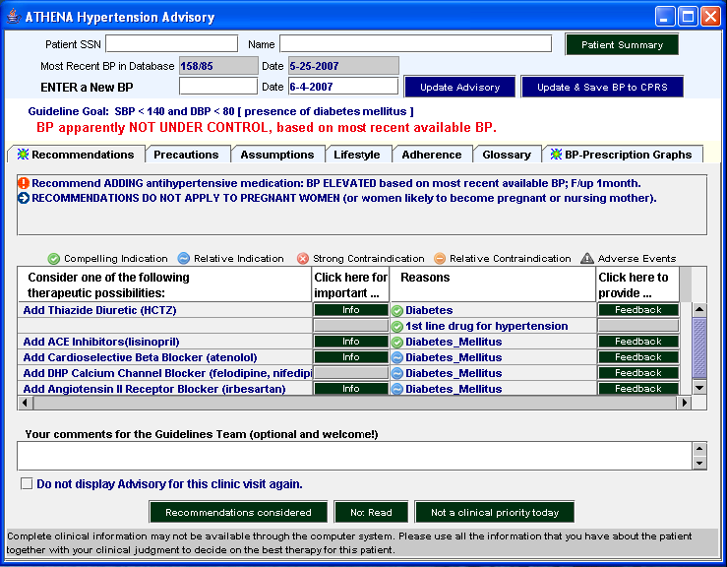Figure 1: Test Patient

The ATHENA-HTN system is designed to give recommendations regarding patients with primary hypertension who are likely to fit the standard hypertension guidelines. It is NOT intended for use with patients with secondary hypertension, or who are pregnant or may become pregnant, as management of hypertension during pregnancy is quite different and some drugs used in standard guidelines are hazardous to use in pregnancy. It is also not intended for use with patients with marked renal insufficiency, or whose hypertension requires more than 4 drugs, or who have other conditions that would make their hypertension management fall outside the standard guidelines. (Please see “Other Information” for specific exclusion criteria.)

When does the Hypertension Advisory pop up?
The Hypertension Advisory will pop up when a patient with a diagnosis of hypertension meeting the inclusion criteria has a scheduled visit to a primary care clinic and the primary care provider is enrolled in the ATHENA system. The Hypertension Advisory will usually be available three days before and one day after the scheduled appointment as well as on the day of the visit. Please note that after the visit the patient’s information may change (prescription, BP values, lab data, etc.) and since data is refreshed nightly the recommendations may change. You can also request not to be shown an advisory window again for a particular visit. For example, after sending the patient to the lab and you may not need to see the advisory again after the patient comes back from the lab.

How do you close the pop-up window?
You can close the window by clicking on: the in the upper right hand corner of the window, or the “Recommendations Considered”, “Not Read” or “Not a clinical priority today” buttons at the bottom of the screen

What happens when you click outside the pop-up window?
If you click outside the pop up window it will minimize and a “coffee mug” icon will appear on the taskbar at the bottom of the screen. To see the Hypertension Advisory again click on the “coffee mug” icon. When the CPRS window closes, the ATHENA window closes as well.

Top third of “ATHENA Hypertension Advisory” Pop-up window
“Most Recent BP in Database” field and “Date” field: displays most recent BP in VA database and corresponding date.

“Patient SSN” field: patient social security number
“Name” field: patient name
“Patient Summary” (button): this will pop up a “Patient Summary” window (see below) with information on vitals, adverse reactions/allergies, active antihypertensive drugs, lab values, related comorbidities and other comorbidities

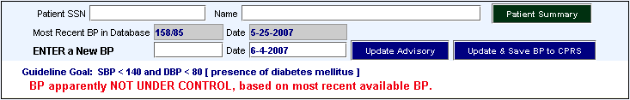
“Update Advisory” (button): will update recommendations based on BP inserted in “ENTER a New BP” and store the BP in the ATHENA database- not CPRS!
Figure 2: Test Patient
“ENTER a New BP” and “Date” field: allows clinician to insert BP and update the hypertension advisory. This BP is not stored in CPRS
Statement about BP control according to “Most recent BP in database“ or BP inserted in “Today’s decision BP” field: which ever has the most recent date.

“Update & Save BP to CPRS”” (button): will give you the option of writing the blood pressure to VistA/CPRS as well as updating the recommendations on the screen – will be activated after all participating VAMCs install the software for it. Until then it will be grayed out and not functional.
“Guideline Goal” BP: Target BP for the individual patient based on presence/ absence of comorbitidies.

Patient Summary window

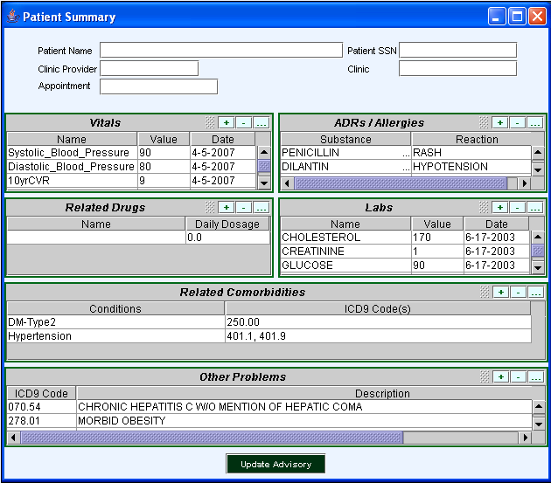
Comorbidities relevant to the choice of antihypertensive drugs. Diagnoses for comorbidities are retrieved from the problem list, inpatient discharge diagnoses and encounter forms. If incomplete, please update in CPRS.
Scroll bars: click to scroll up or down
Daily dosage calculation is based on the following formula:
[(strength of dosage form) x (number of dosage forms)] /days supply
If extra dosage forms (tablets) are dispensed there may be an overestimation of actual daily dose.
Figure 3: Test Patient

This window is a quick way to see the patient’s clinical information related to decisions about hypertension management. If you would like to see how a change in the patient’s clinical data would change the recommendations, you can make changes on the Patient Summary and then use the Update Advisory button on the Patient Summary to update the recommendations. You can include/exclude diagnoses, and modify medications and labs to change scenarios. Diagnoses are retrieved from the problem list, inpatient discharge diagnoses and encounter forms. If incomplete, these should be updated in CPRS. NOTE: Changes on this screen are not written back to CPRS – they are purely for you to see what would happen if the data were to change.

Middle third of “ATHENA Hypertension Advisory” Pop-up window

- This part of the Advisory window contains 7 “tabs” (figure 3): (The currently displayed tab is gray and hidden tabs are blue.)

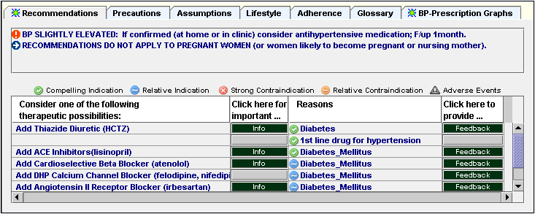

Recommendations Tab

Icons are used to highlight type of indication or contraindication in “Reasons” column based on data from the patient’s VA file.
“Consider the following therapeutic possibilities”: therapeutic recommendations to increase dose, add, substitute or delete specific drugs
“Reasons”: reasoning underlying the specific drug recommendation with icons to show, for example, if this is a “compelling” or “just a “relative indication

Click here for important…”: “Info” button is activated when there is important information for a specific drug recommendation.
“Click here to provide…”: You can send us Feedback if you like about this recommendation.

Important statements about BP control, recommended action, prescriptions not being filled and strong contraindications.

Precautions Tab

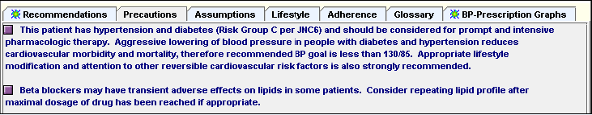

- This Precautions tab contains statements with information specific to this patient but not necessarily linked to a drug recommendation.

Assumptions Tab

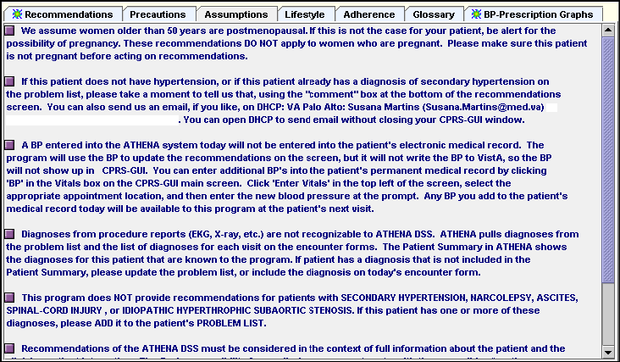

- This Assumptions tab shows assumptions made by ATHENA-HTN. For example, if data is missing from database ATHENA will assume no diagnosis of BPH, normal value for creatinine and no adverse events to active prescription and recommended drugs.

BP-Prescription Graphs Tab

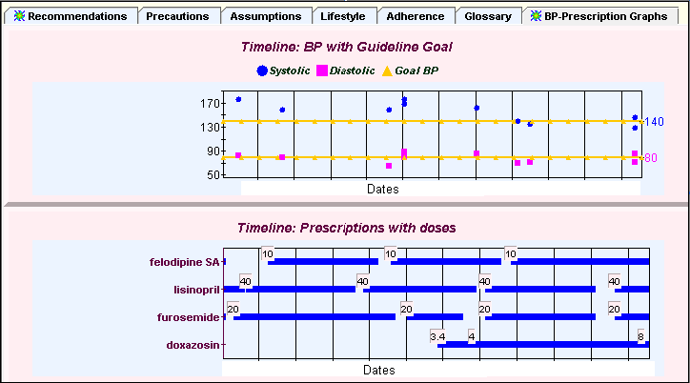
Guideline goal
BP levels

- This tab displays historical graphs of BP and prescription data using data from FY1997 to present. Drug doses are displayed in boxes, while the yellow line indicates the blood pressure goal recommended for the patient.
- The prescription graph displays drugs dispensed. Gaps in the lines of the prescription data may reflect a lack of medication adherence.

Lifestyle Tab
- This tab contains general information related to lifestyle issues that may have an impact on hypertension, such as diet, smoking cessation, exercise and alcohol consumption,

Adherence Tab
- This tab offers general suggestions of ways to improve patient adherence to therapeutic regime.

Glossary Tab
- Definitions of the terms used in the pop-up window can be found in this tab.

Bottom third of “Hypertension Advisory” Pop up window
Comments box field: type in your comments for the guideline team. They are welcome!

“Not a clinical priority today” button: press this button to close the window if the patient has other clinical priorities than the management of hypertension.
“Do not display Advisory for this clinic visit again” check box: Check this box if you do not want to see Advisory for this patient again relative to this visit

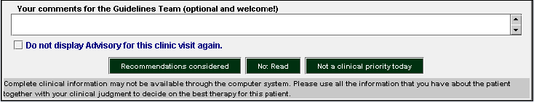
“Recommendations considered” button: press this button to close the window after you have reviewed the content.

“Not Read” button: press this button to close the window if you have not reviewed the content.

Disclaimer

Other Information

- Computer screen resolution should be set for 1024x768 (From your desktop, go to My Computer\Control Panel\Display\Settings) to best view CPRS and the ATHENA Hypertension Advisory.

- A BP entered into the ATHENA system today will not be entered into the patient's electronic medical record. The program will use the BP to update the recommendations on the screen, but it will not write the BP to VistA, so the BP will not show up in CPRS-GUI. Any BP you add to the Vitals Signs part of the patient’s medical record today will be available to this program at the patient’s next visit. NOTE: we are working with VA computer staff on a system that will give an option for the BP to write-back to CPRS in the future – this is in testing phase now.
- Data can be added or deleted from Patient Summary. However, this data will be stored in ATHENA’s database only. It will not change what is in the CPRS/VIstA. If the clinician wishes to update patient data he/she should do so through CPRS.

- The program attempts to exclude cases based on the following criteria when identified in the computable data:
- General:
  - Age < 18 years
  - Women who are pregnant or of childbearing age (age < 50 years)
  - eGFR (MDRD formula) < 30
- Drug related:
  - Currently on > 4 antihypertensive medications
  - Active prescription for cyclosporine, spironolactone, minoxidil, or tacrolimus
- Diagnosis related:
  - Diagnosis of secondary hypertension
  - Diagnosis of malignant hypertension
  - Diagnosis of renovascular disease
  - Diagnosis of narcolepsy
  - Diagnosis of ascites
  - Diagnosis of spinal cord injury
  - Diagnosis of idiopathic hypertrophic subaortic stenosis
  - Diagnosis of transplant (bone marrow, heart, lung, kidney, intestine, liver, pancreas, peripheral stem cells)

- What if ATHENA recommendations don’t apply to a particular patient? If you think that a patient meets the exclusion criteria but has not been excluded, we’d like to hear about that so that we can trouble-shoot the problem – you can send us a text message using the feedback box at the bottom of the screen. If the patient doesn’t have one of the identified exclusions but you think that for this particular patient the recommendations don’t apply, we are also interested in hearing about this, although we also know you are very busy so we don’t expect to hear about all of these cases. It is very easy to bypass the ATHENA alert if you believe it is not applicable to a particular patient -- just click in CPRS outside the ATHENA window. If you want us to exclude a specific patient from displaying ATHENA alerts, you can make a request by typing in the feedback box and giving us the reason for exclusion (for example: terminal, advanced dementia, etc.)
- The ATHENA Hypertension Advisory is available for viewing 3 days before and 1 day after the patient’s clinic appointment date as well as on the appointment date. The data are refreshed (updated) daily so new prescriptions, lab data, diagnosis and BP measurements post clinic visit will be incorporated into the new recommendations. For example if a patient is seen in clinic, BP is inadequately controlled and a new drug is added to his/her prescription (and the prescription is filled at the VA), when viewing the Hypertension Advisory one day after clinic this new drug will be listed with the patients current hypertensive drugs and the most recent BP will be the reflecting the inadequate control seen in clinic the day before. If you use CPRS the next day to check on labs or to sign your note, you may see that new diagnoses or labs from the visit date change the recommendations you see from what was displayed the day before.
- If the pharmacy database is missing information to calculate the drug dose, ATHENA will display the drug in the patient summary with a 0.0 dose. Providers may want to check the pharmacy prescription if this happens; this may have to do with how VistA holds pharmacy information (if you see a problem with this, please enter a comment into the feedback window). ATHENA will not generate recommendations about a dose increase but will alert the clinician with a message in the box above the table of drug recommendations.

Disclaimer

Recommendations from ATHENA-HTN must be considered in the context of full information about the patient and the clinician-patient interaction. The final responsibility for medical management rests with the prescribing/treating clinician (physician or nurse practitioner). While we have made every effort to ensure that the recommendations generated by ATHENA-HTN reflect the current evidence for management of hypertension, we cannot guarantee that the program will generate a recommendation for the best treatment in all cases. Please use your clinical judgment in evaluating recommendations from ATHENA-HTN. If you see recommendations that you believe represent errors in the program, please call them to our attention by entering text comments or contacting us by phone/email.
The information contained in ATHENA-HTN is intended to supplement the knowledge of health care professionals regarding therapeutic management of diseases. THIS INFORMATION IS ADVISORY ONLY AND IS NOT INTENDED TO REPLACE SOUND CLINICAL JUDGMENT OR INDIVIDUALIZED PATIENT CARE in the delivery of health care services. The user is advised that, although the information is derived from research literature and is subject to review and approval by medical experts, we cannot guarantee either its comprehensiveness or currency. The user of this software assumes sole responsibility for any decisions made or actions taken based on the information contained in this software, including but not limited to the therapeutic suggestions.
The Department of Veteran’s Affairs disclaims all warranties regarding such information or suggestions, whether express or implied, including any warranty as to the quality, accuracy, currency or suitability of this information or therapeutic suggestions for any particular purpose.
The Department of Veteran’s Affairs shall have no liability to any person, or entity with regard to claims, loss, or damage caused, or alleged to be caused, directly or indirectly by the use of this Software or the information contained within.

Data shown in this training manual are consistent with The Health Insurance Portability and Accountability Act (HIPAA) Privacy Rule

